This is the neural network architecture:
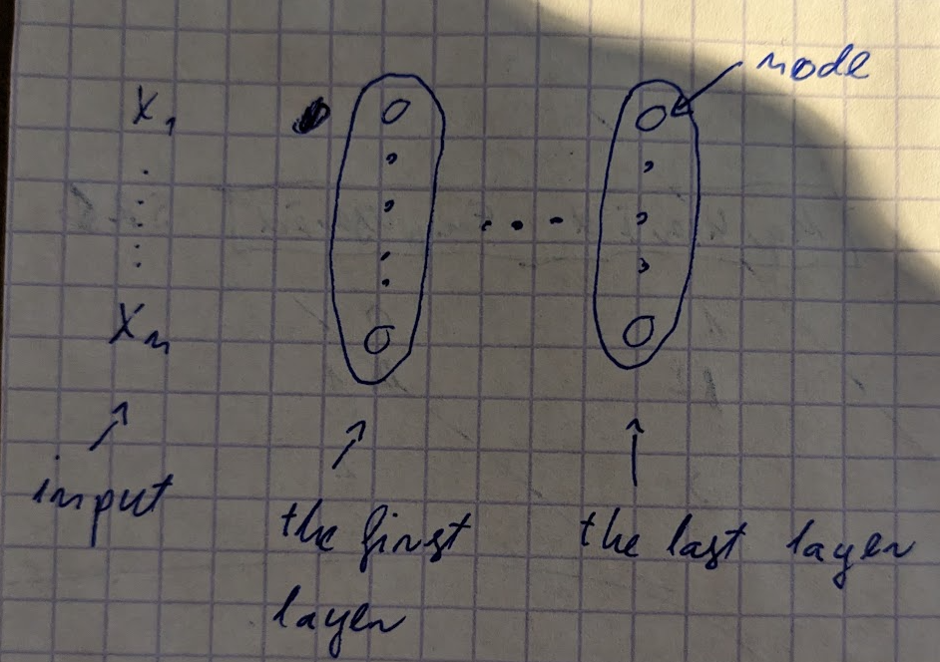

It constists of layers and each layer consists of nodes. Each node is a function (so called activation function). This is how the output is being calculated:
- Each input value is multiplied by a weight, we add them together and we add to them a bias. Weights and biases are just numbers. This sum is an argument to an activation function of the first node
- Then we again multiply input values by weights and we are adding a bias and this is an argument for an activation function of another node but this time we are using different set of weights and different bias. Each node has associated set of weights and biases.
- Each node returns a single number. A whole layer returns a sequence of numbers and this is an input for another layer.

In order to train a neural network we are using the backpropagation. We are calculating a derivative of a loss function. Value of a loss function depends on an output of a neural network (neural network is a function. It is a composition of other functions which are nodes). We calculate that derivative with respect to the weights and biases and we are using those derivatives to change our weights and biases such that we obtain a smaller value of a loss function.

Why we are adding a bias
Let’s assume that our network consists of only one node and activation function if the relu function. If in our dataset we have an example where input x = 0 and corresponding y = 2, then no matter what weights we choose the output of a node will be 0 because we multiply x = 0 by weights that equals 0 and relu(0) = 0. So we will never get 2 as the output.

Backpropagation
Backpropagation is a method of updating model’s parameters (weights and biases). We are calculating gradients of a loss function for every model’s parameter and then use those gradients in order to update parameters in such a way that loss decreases.

Optimizer
We are using so called optimizer in order to update model’s parameters. It provides a formula for how to update parameters using calculated gradients.

Optimizer states
Optimizer calculates states based on gradients which are used to update model’s parameters.

For example in case of Adam optimizer we calculate them and use them to update parameters this way:
